**[Best Free Keylogger](https://bestxsoftware.com/)**

**Introduction:**

Best Free Keylogger is a PC monitoring utility that works totally invisibly in your computer. This software can monitor keystrokes; Chat, Internet activity, Visited URL, Clipboard text copy, File copy monitoring and also can take screenshots for previously setup schedule task. This software is the best solution to monitor what children are doing with their computers when parents are not available at home or else can monitor the employee’s duty whether they are doing that properly or not with the computer.

This software is totally invisible and only user who installed this software in to the computer can see it. The attractive user friendly interface provides user to collect data easily. User can simply coordinate and control this software and also can do filtering to get the necessary data. Thumbnail or full screen mode can use specially to see the screen shots and also slide show feature helps to simplify the screenshots.

Time scheduling task is available to activate this software for a particular time period and can activate only selected user accounts. Also it can enable or disable in selected applications, automatically remove early data and automatically uninstall by itself for the previously scheduled time are the advanced features available in this software. Best Free Keylogger supports for the methods to monitor data from another computer. It can automatically upload in to the FTP host and Emailed to the previously scheduled time frame. In a network it can automatically transfer data to the main computer. It has a USB delivery system and when it connects to the computer it automatically starts to transfer reports to it. (USB device must previously configured with the software)

1. **Installing:**

* Download the program from the link <https://www.easypcmod.com/5-best-free-keylogger-windows-1299>
* Install the program on your device, do not forget to read the license agreement before proceeding, as for file destinations We recommend using the default location

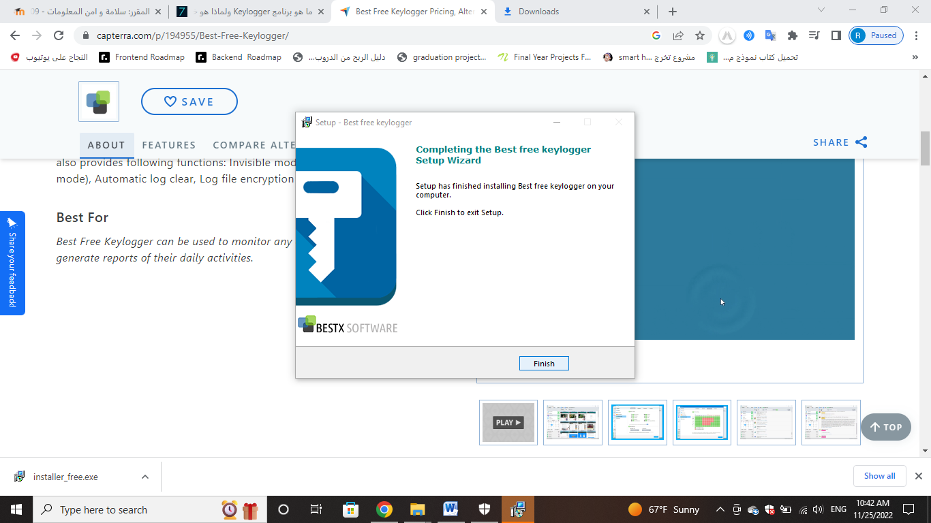

1. **Getting Started:**

* **Unhide**

**The first way:**

1. Press WIN+R
2. Type "unhide" in Run dialog
3. Do not press Enter
4. You will see an interface to set the password for the program
5. Set a password, then click Save
6. Enter the password to log in

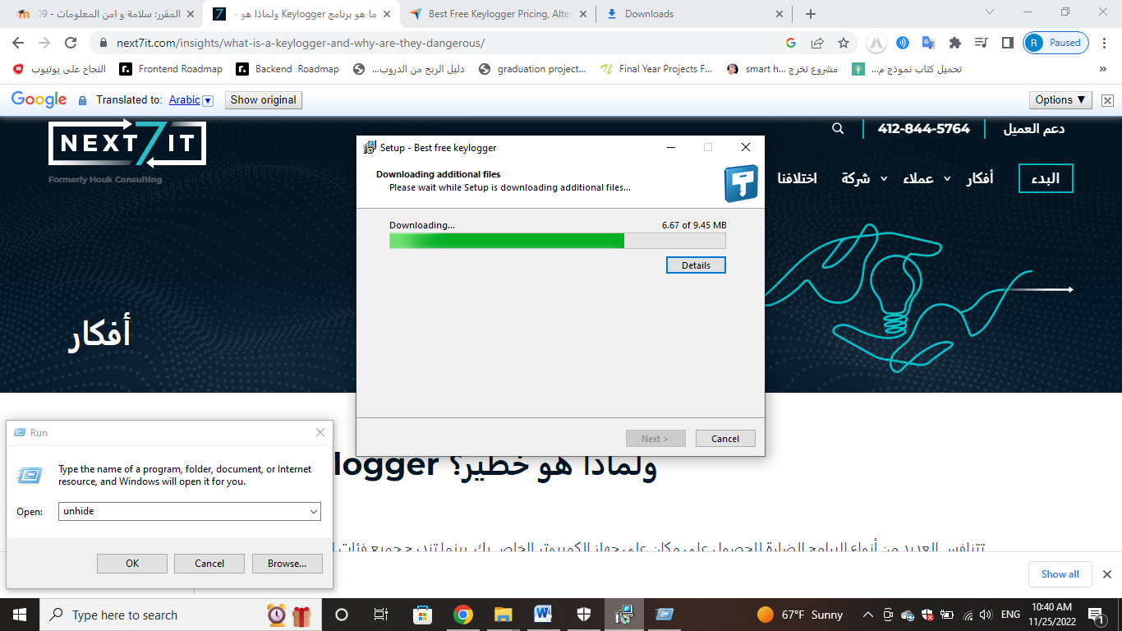 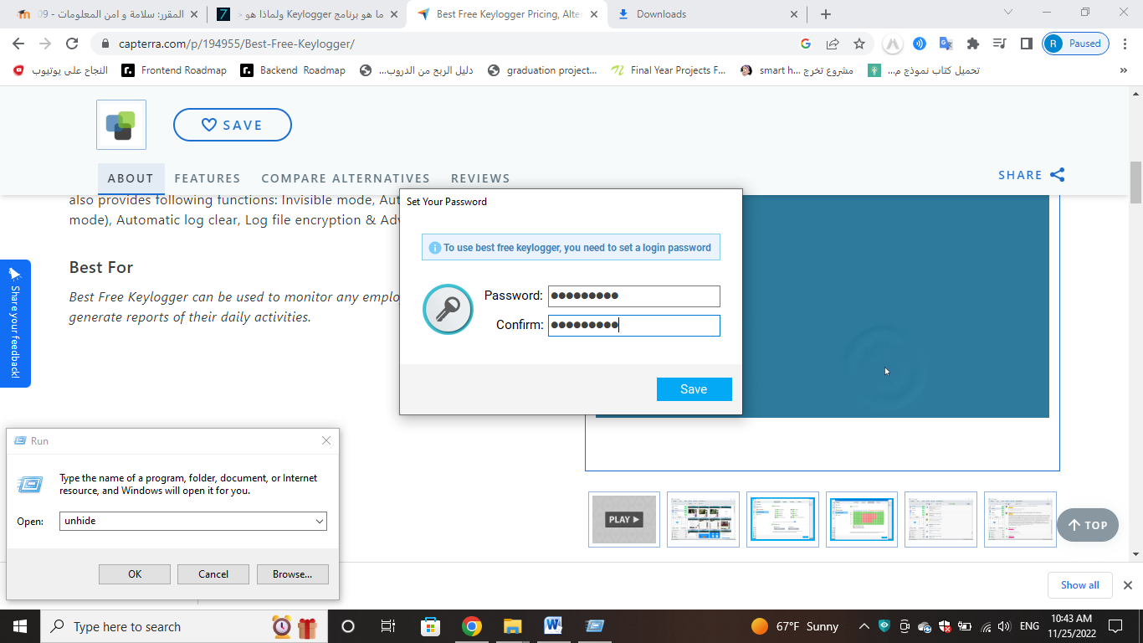

**The Second way:**

1. Press Shift + Ctrl + Alt + K together.
2. Enter the password to log in

* **User Interface**

Quick Filter

Report Viewer

Smart Read Button

Zoom Buttons

Main Section

Calendar

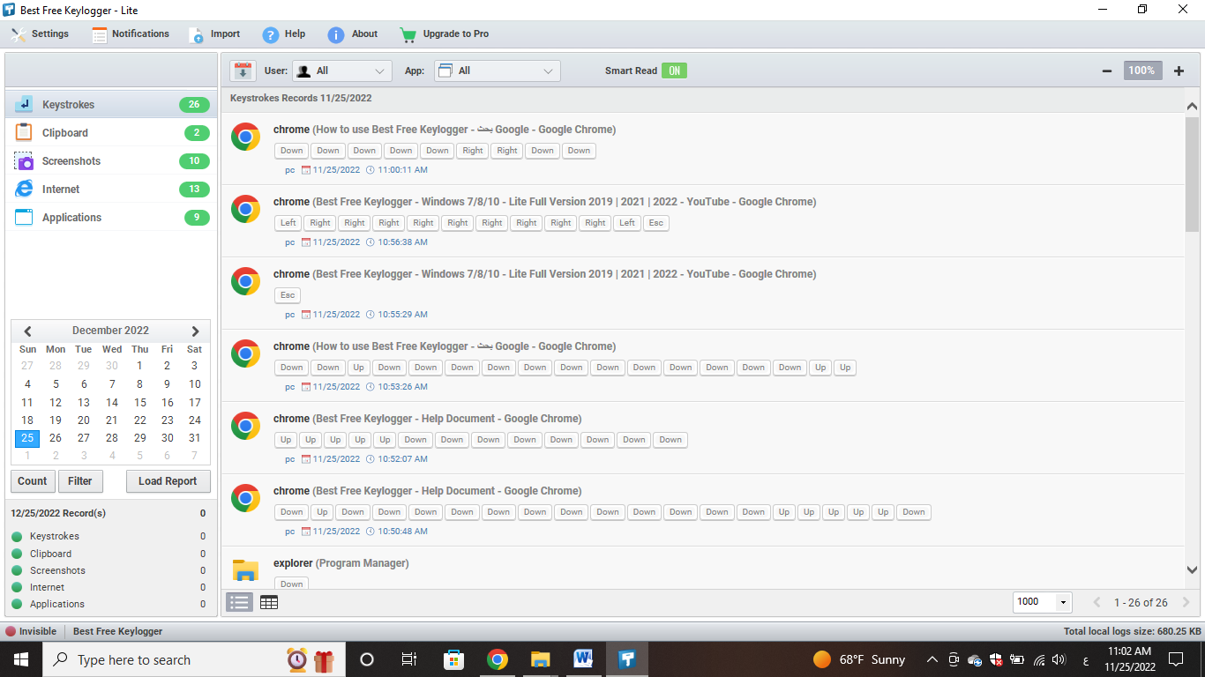

Add, Remove Filter Button

Load Report Button

Status Panel

Status Bar

Toolbar - (Save, Import Log Files, Help, About)

* **Settings**

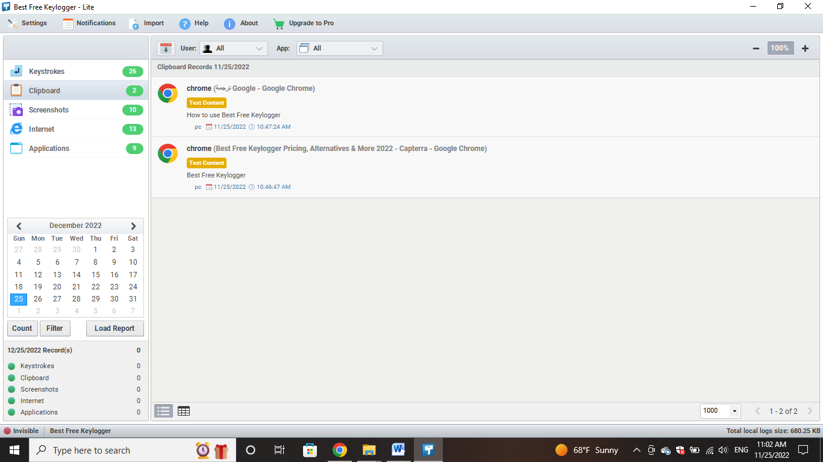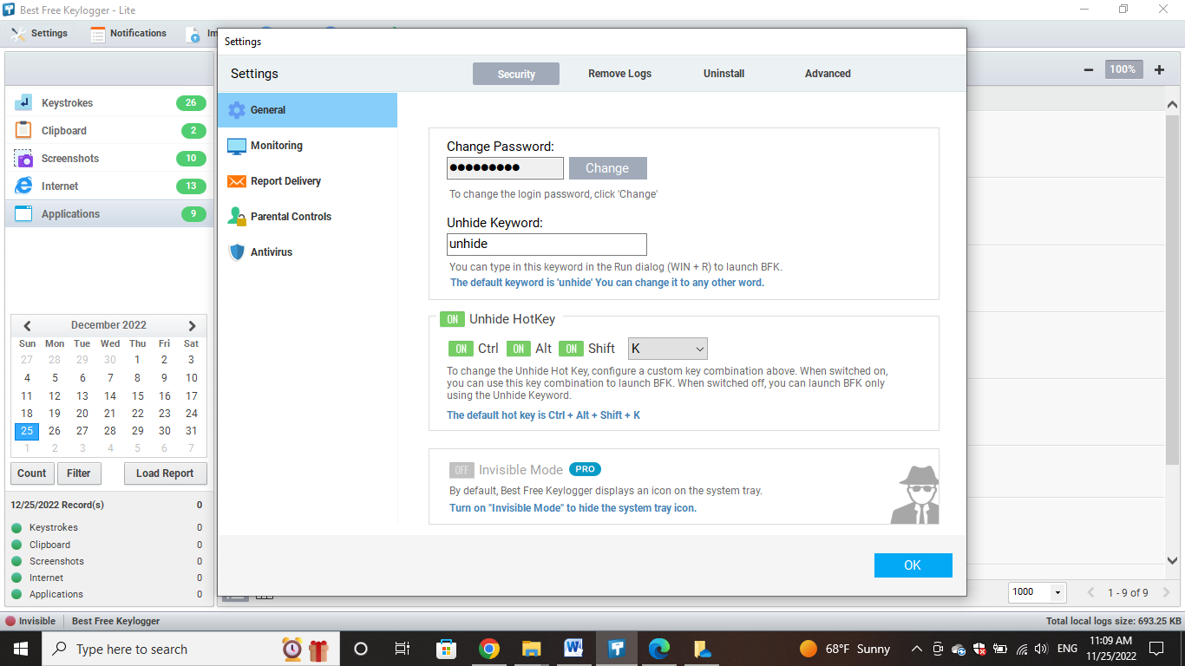

1. **General Settings**
2. **Security**

**to change the password:**

Type your new password into the box, then click Change

**Unhide Keyword:**

is a command used to type on Run Dialog to identity to activate Best Free Keylogger. This can change from here.



**Unhide Hot Key:**

to unhide or hide Best Free Keylogger interface

**invisible Mode:**

Hide or show the program icon on the system

1. **Remove Logs**

**Automatically clear logs:** Activate this option to automatically removing logs, or stop monitoring in a limited hard disk space.

When complete Maximum log size (MB) then this command will execute

**Remove logs after delivering:** Activate this option to remove logs automatically after delivered by E-mail, FTP (file transfer protocol), Network (local area network), and USB systems.

**Remove logs now:** To remove all logs click on this button

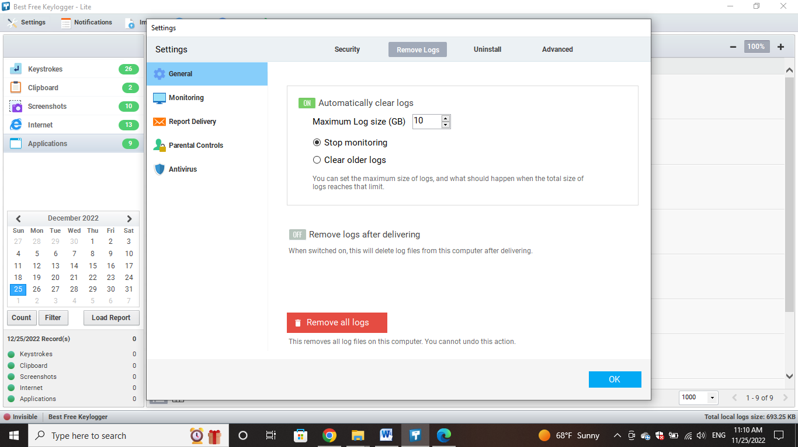

1. **Uninstall**

**Auto uninstall(silent mode)on:** Best Free Keylogger can automatically uninstall after a particular time period. Uninstalling is executing in a silent mode and it doesn’t indicate to the user. To activate this enable option and give future date in Set Date:

**Uninstall now:** Best Free Keylogger can uninstall by clicking Uninstall now button and at the same time it removes log file

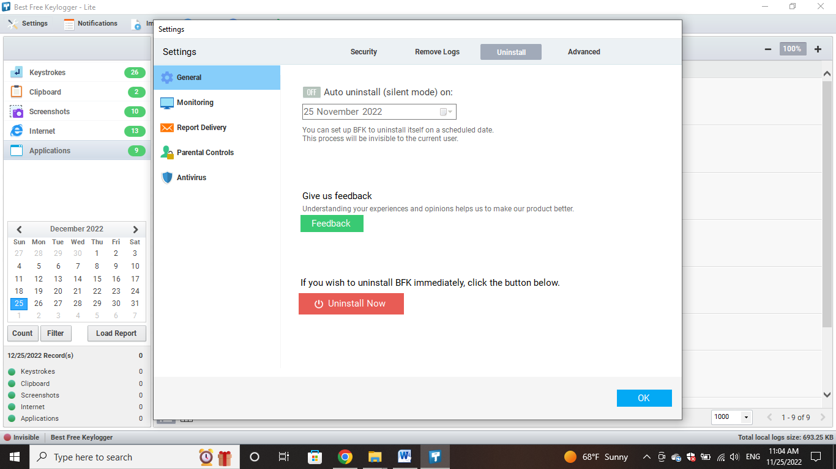

1. **Advanced**

With it, you can perform three operations:

1. Delete web filtering cache

2. Copy stack trace file

3. Change Advanced Delivery Settings

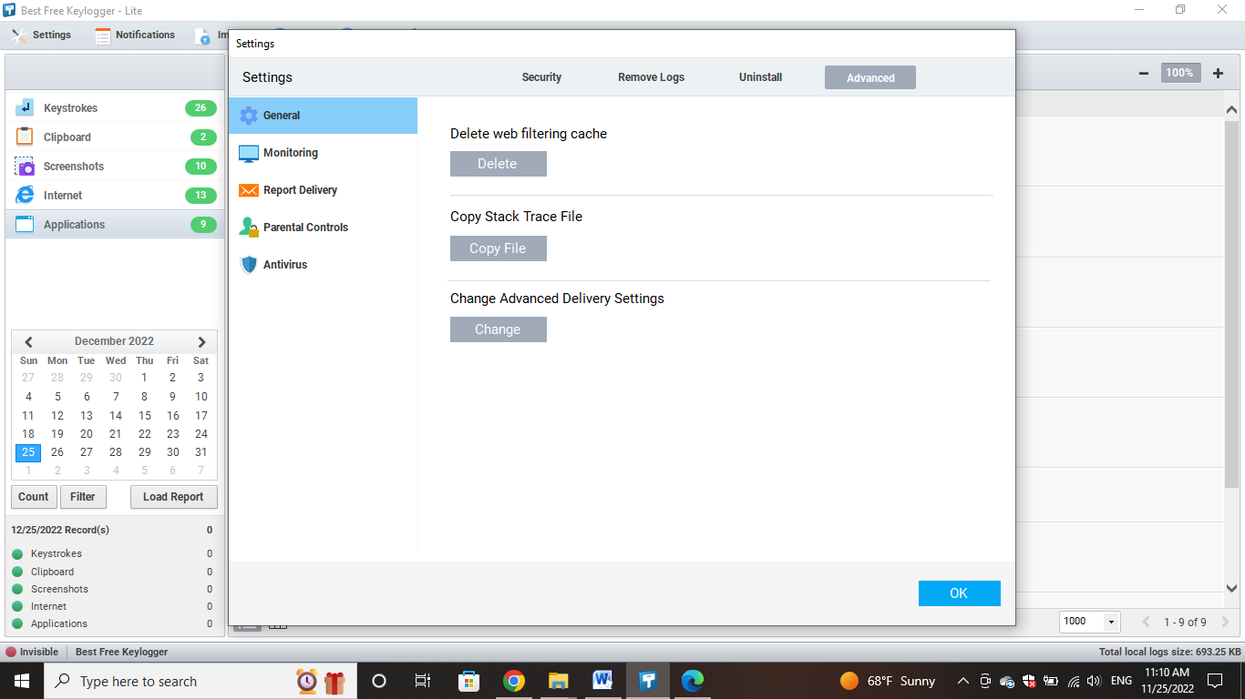

1. **Monitoring Settings**
2. **Monitoring**

You can activate or deactivate the following sections:

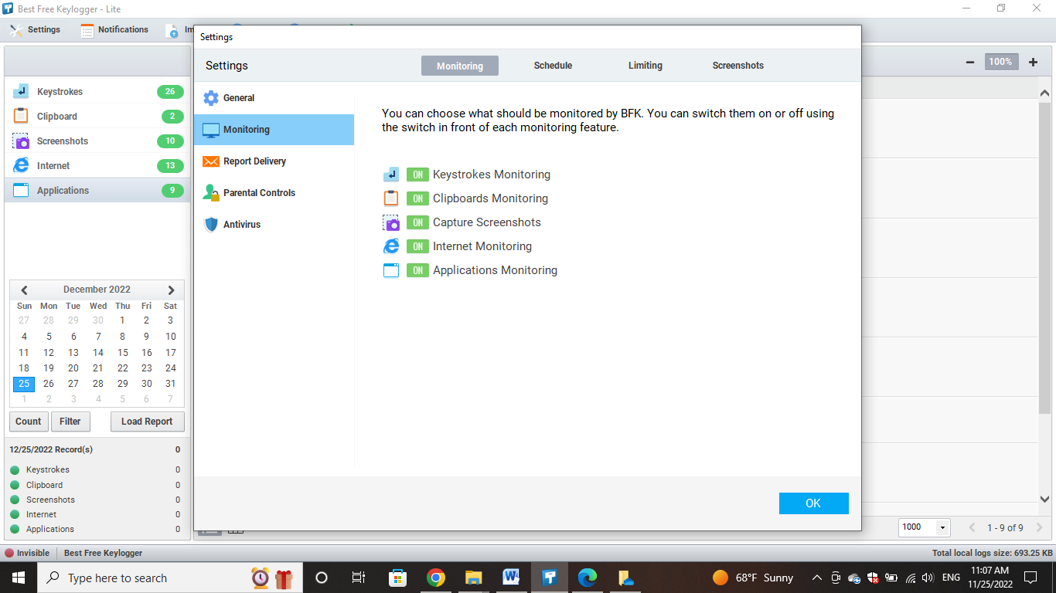

* **Keystrokes Monitoring**

to track, capture, record and log all keyboard activity by a user or employee whether into web browsers, instant messages, e-mails, applications, documents and programs.



* **Clipboards Monitoring**

Clipboard monitoring allows you to monitor Cut, Copy, and Paste operations performed on the Client computer.



* **Capture Screenshots**

he screenshot monitoring allows the user to access screenshots of someone else's computer.

Can enlarge the image by clicking on selected image.

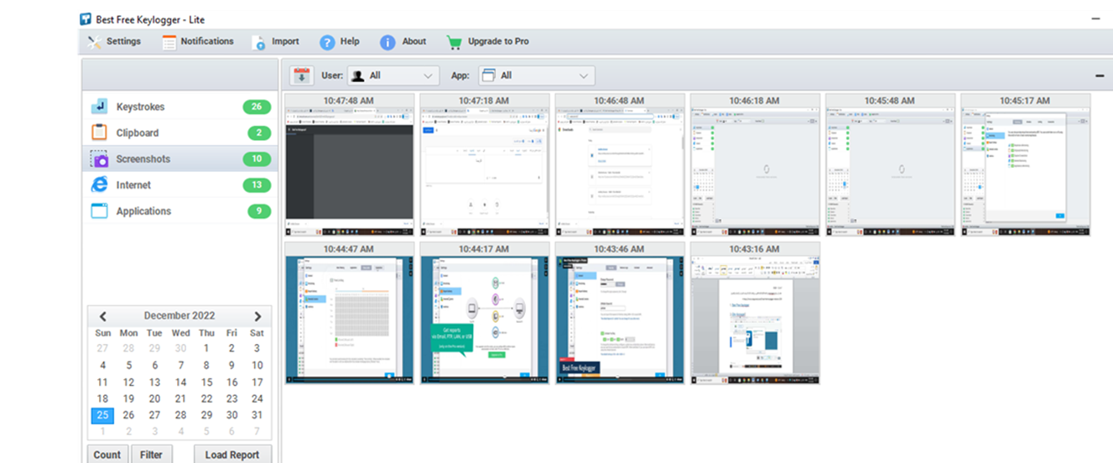

* **Internet Monitoring**

to track websites visited.

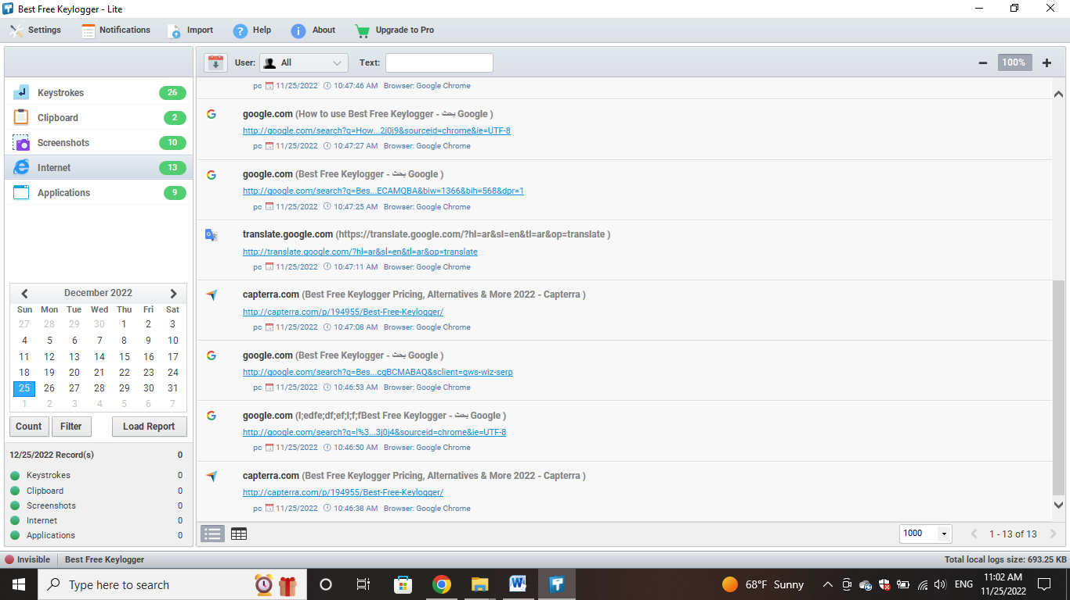

* **Applications Monitoring**

to track application visited.

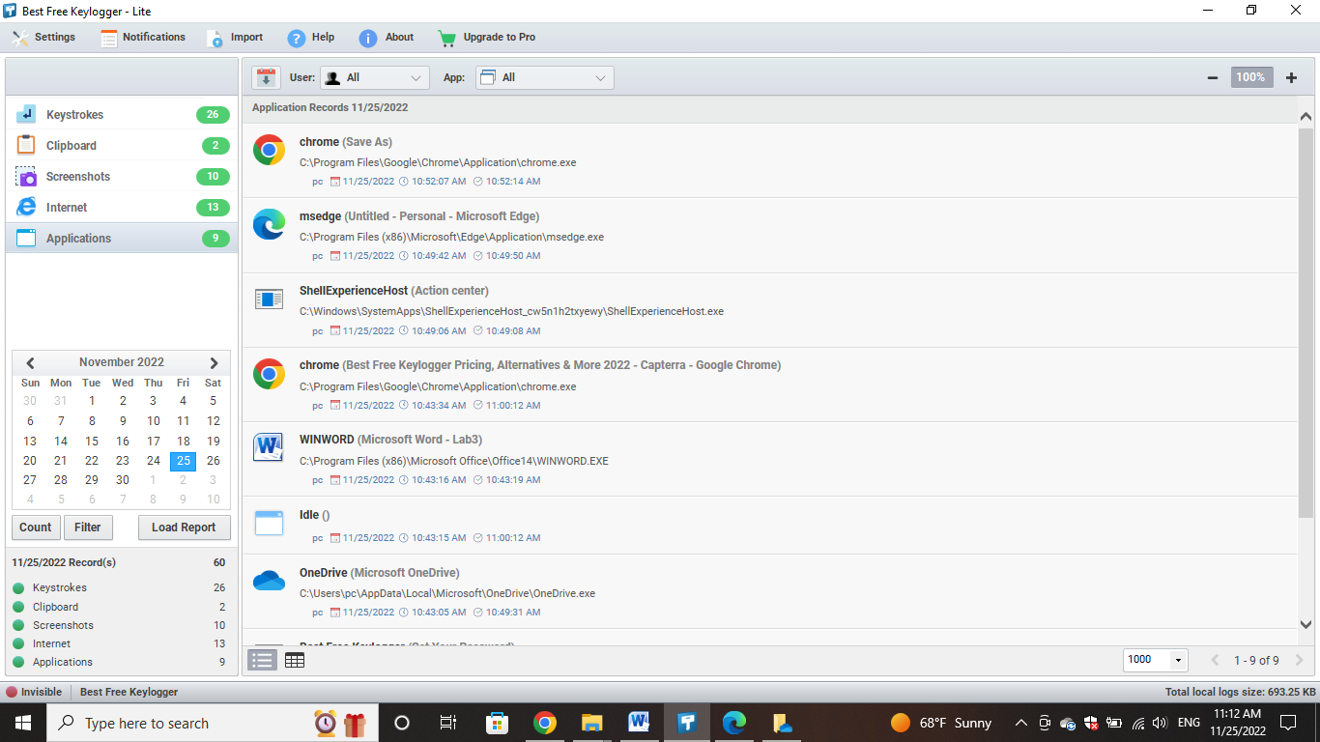

1. **Schedule**

Select Monitor only or Do not monitor options and give the active or deactivate time periods in from and to.

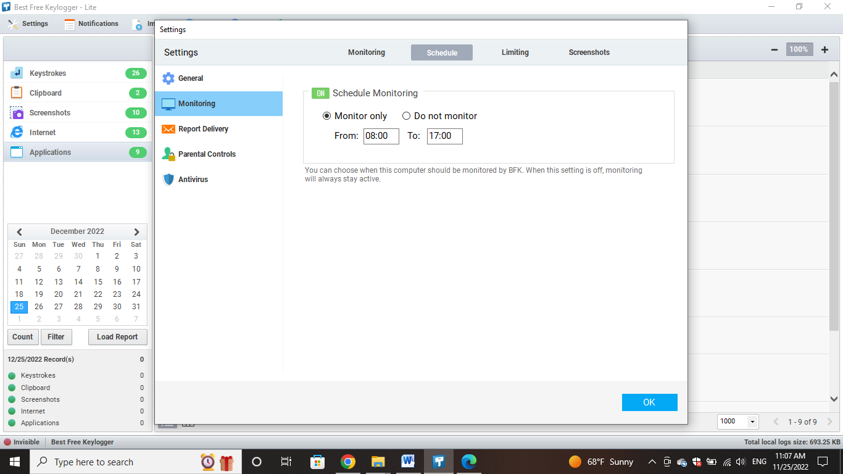

1. **Limiting**

**Monitor only following user:**

limit the amount of monitoring users.

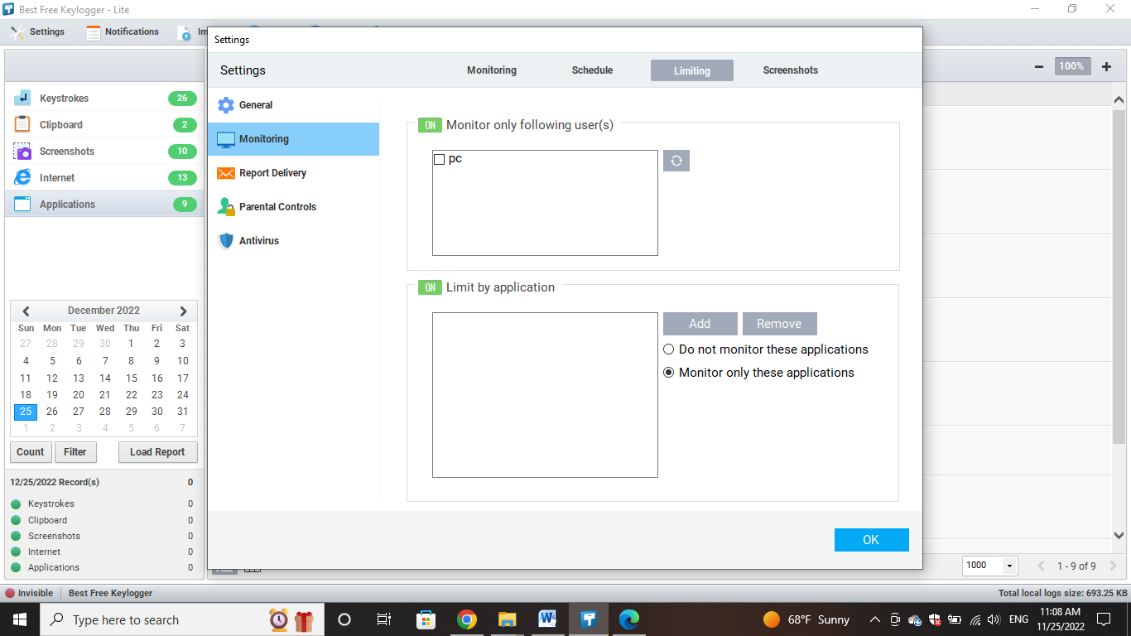

**Limit by application:**

Press the Add button to add applications to the list which needs to monitor or not by selecting these two options, Monitor only these applications or Do not monitor these applications. Press the move button to remove added program. To monitor all applications please uncheck this option



1. **Screenshots**

**Screenshot quality:** Quality of the screenshots can be categorized in to Very high, High, Medium, Low. When the qualify gets high it increase the capacity of file size as well.

**Screenshot interval (sec):** This can arrange the screenshots that we have to take within how many seconds.

**Capture only the active window :** When this option is in active mode Best Free Keylogger takes the screenshots of the applications on the top window. To take full screenshot please uptick this

**Do not capture when screensaver is running**: Please activate this to avoid taking screenshots when screensaver is enabled.

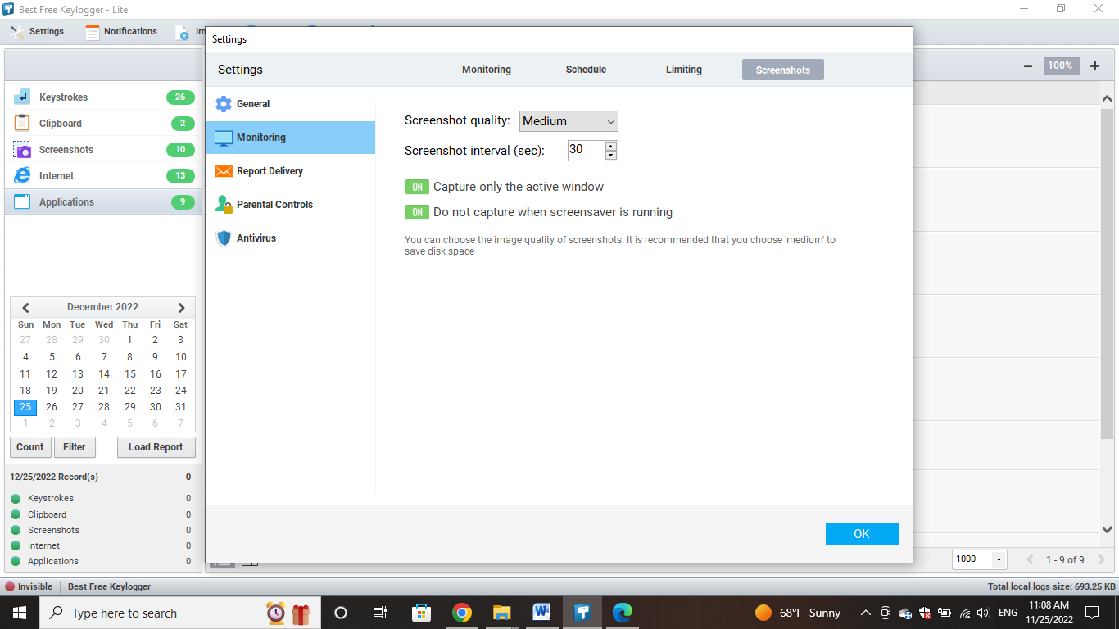

1. **Report Delivery**

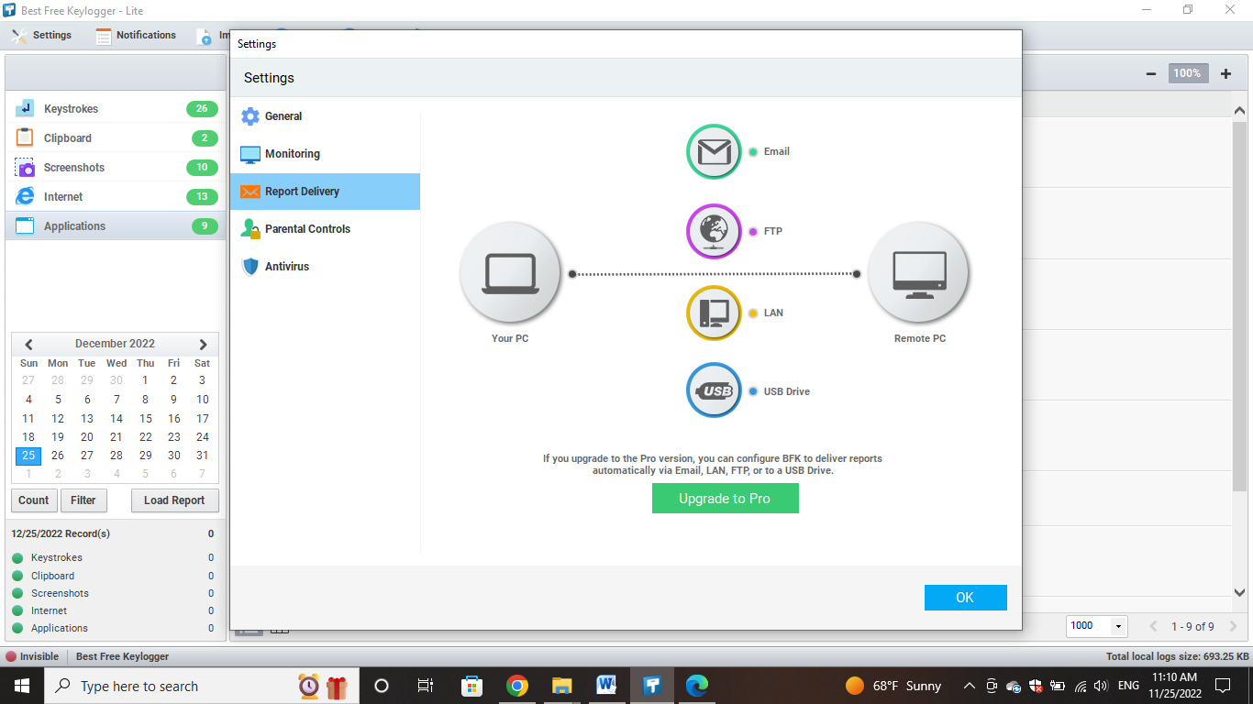

**Email**

This part enables user to deliver Best Free Keylogger reports through E-mails.

1. Enable the Enable Email Sending option.

2. Email Address: Enter your email address here. All log files send to this address.

3. SMTP Server: Enter your SMTP server name.

4. Port: Enter port number.

5. Presets: If your E-mail address belongs to one of this services then above SMTP server and PORT numbers can gain from here.

6. User Name: This must be the E-mail address.

7. Password: Enter your email password.

8. Mail Subject: Mention the subject of an E-mail here.

9. Test Click this button after entering the correct information. Test E-mail will send to your E-mail address. If there is problem then it’ll indicate.

10. Send email every (min): Input within how many minutes that E-mails have to send. When computer is in offline then E-mails doesn’t send and waiting for the computer to be online.

11. Do not send screenshots: The sizes of the screenshots logs are large and if Internet connection speed is not enough then sending screenshots can slow down your computer. When this option activates then screenshots doesn’t send and all the other data will send to the destination E-mail address usually.

12. Email logs now E-mails just send by clicking on this button

**FTP (file transfer protocol)**

This part provides the facility to Deliver Best Free Keylogger detail reports to the online host server.

1. Enable the Enable FTP Uploading option.

2. FTP Host: Enter your FTP Server/Host address here.

3. Directory: Enter directory name where the log files must uploading.

4. User Name: Enter your FTP user name.

5. Password: Enter your FTP password.

6. Test Click this button after entering the correct information. Test file will upload to FTP Server/Host. If there is problem then it’ll indicate.

7. Send log every (min): Upload log files every (min): Input within how many minutes that log files have to upload. When computer is in offline then log files doesn’t upload and waiting for the computer to be online.

8. Do not send screenshots: The sizes of the screenshots logs are large and if Internet connection speed is not enough then uploading screenshots can slow down your computer. When this option activates then screenshots doesn’t upload and all the other data will upload to the destination FTP Server/Host usually.

9. Upload logs now Log files just upload by clicking on this button

**Network(LAN)**

Best Free Keylogger provides the facility to Transfer log files from one computer to another computer in a Local Area Network.

1. Enable the Enable Lan option.

2. Network Path: Enter path of the remote computer. By clicking […] button you can browse the path.

3. User Name: Enter remote computer user name.

4. Password: Enter remote computer password.

5. Test Click this button after entering the correct information. Test file will send to remote computer. If there is problem then it’ll indicate

6. Send log every (min): Input within how many minutes that log files have to send.

7. Do not send screenshots: When this option activates then screenshots doesn’t send and all the other data will send to the destination remote computer usually.

8. Send logs now Log files just send by clicking on this button.

**USB**

Log files can copy in to the previously configured USB device with Best Free Keylogger. In here only you have to connect the USB device to the computer and it automatically execute the copy event (Full Invisible). For this you have to configure your USB device with Best Free Keylogger first. And Best Free Keylogger identifies such USB devices only. For some reason if you format the configured USB device then you have to reconfigure it. To activate this facility,

1. Enable the Enable USB option.

2. Connect your USB drive to computer.

3. Click the Refresh button.

4. Choose your USB drive form the USB Drive List.

5. Click the Configure button.

6. Whenever you connect a configured USB drive to the computer, all new logs will be secretly copied.

7. Copy logs now Log files just copy by clicking on this button

1. **Parental Controls**

Parental controls allow you to block and filter upsetting or inappropriate content. They work across your WiFi, phone network, individual apps and devices. Parental controls can help you to: plan what time of day your child can go online and how long for.

1. **Web Filtering**

**Web Filtering**

Parents can manage the websites their children can visit on Chrome, and limit their children's ability to grant permissions to websites.

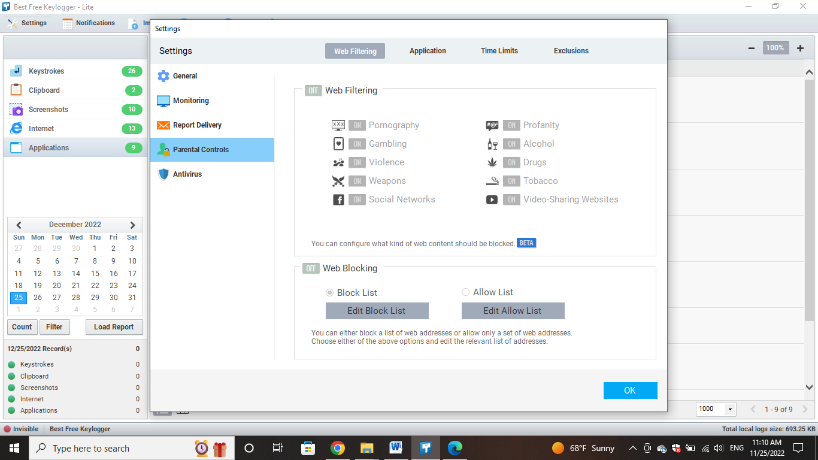

**Web Blocking**

Block a list of web addresses, or allow only a group of web addresses

1. **Application**

Parental can add the apps they want to block from the Add button, or delete the app from the list of blocked apps from the Remove button.

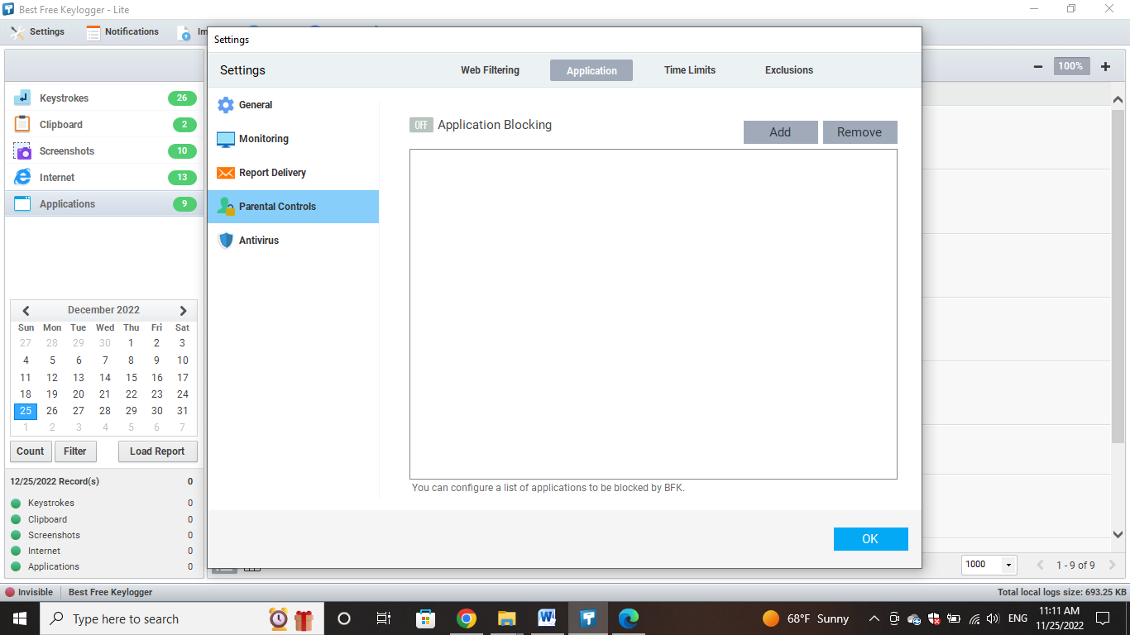

1. **Time Limits**

Parents can specify the browsing time and the time when browsing is prohibited, as the son will not be able to visit any website during the ban hours other than the home page of the browser

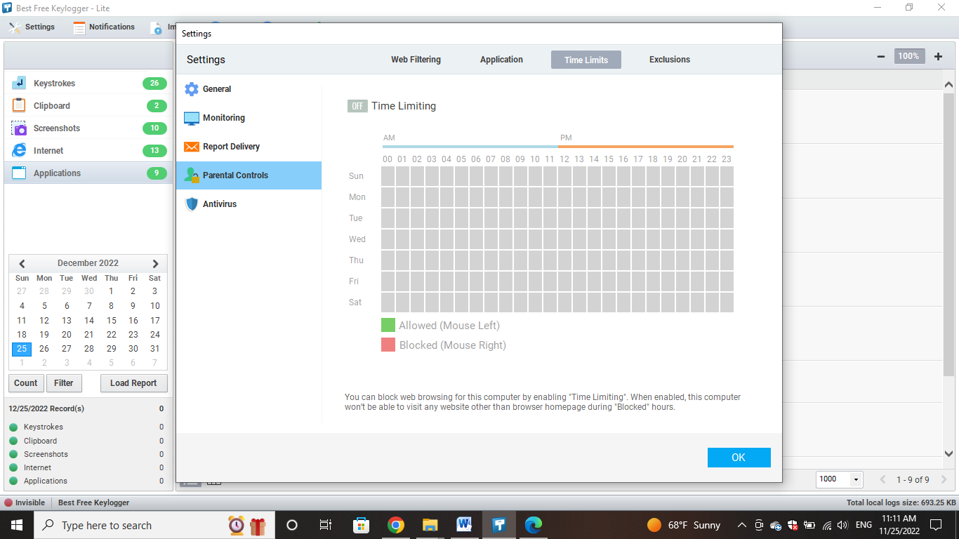

1. **Exclusions**

Exclude websites that use keywords from filtering

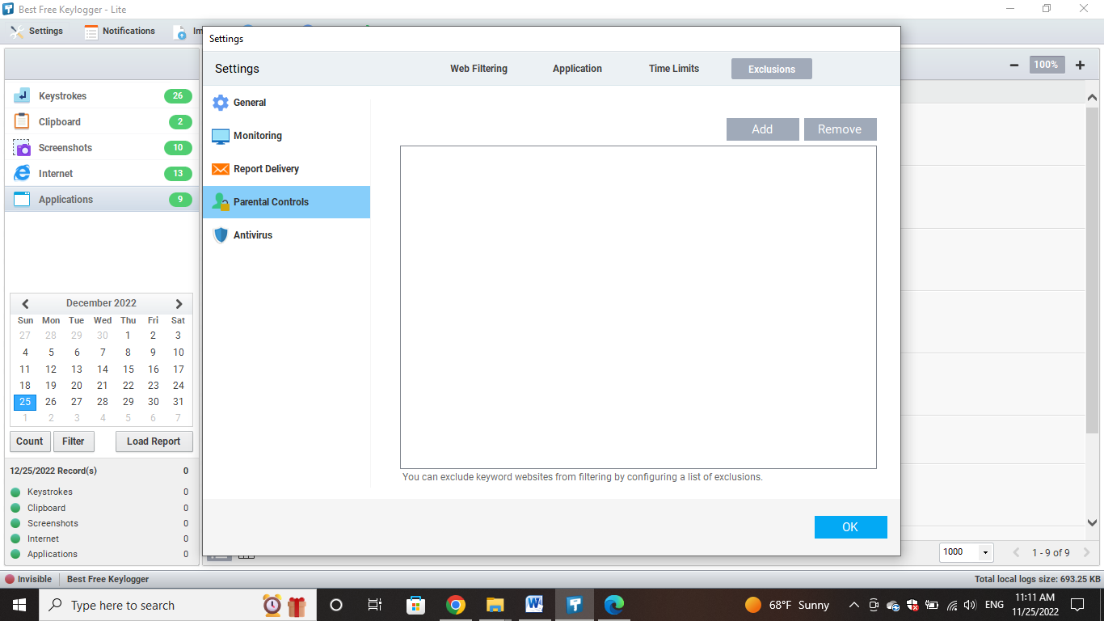

1. **Antivirus**

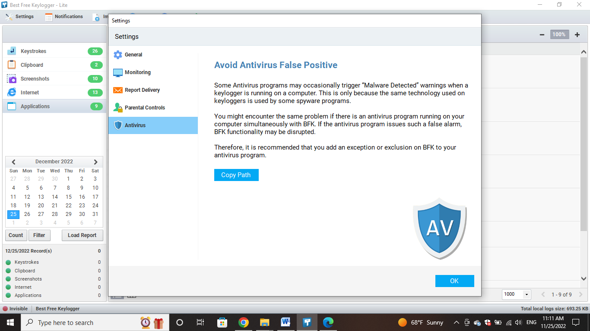

* **Import**

To see the details of the log files delivered by Emails, FTP, Network or USB, first you must import all.

1. Click Import log files button on the toolbar.

2. Add or drag & drop log files (.kelgfile) which you want to import.

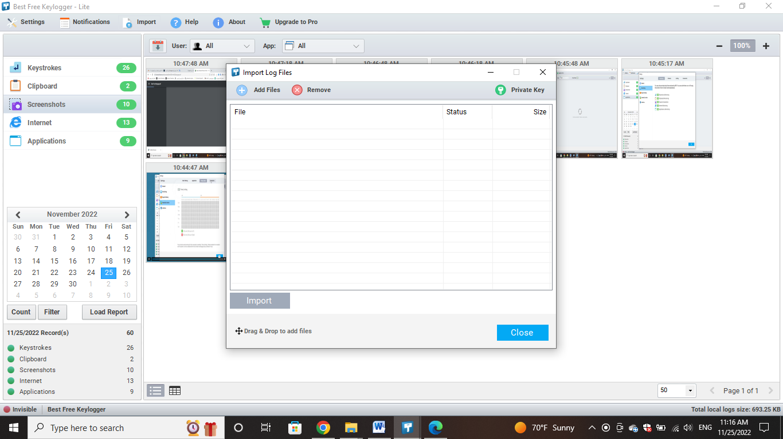

* **Count**

Count the running on a given date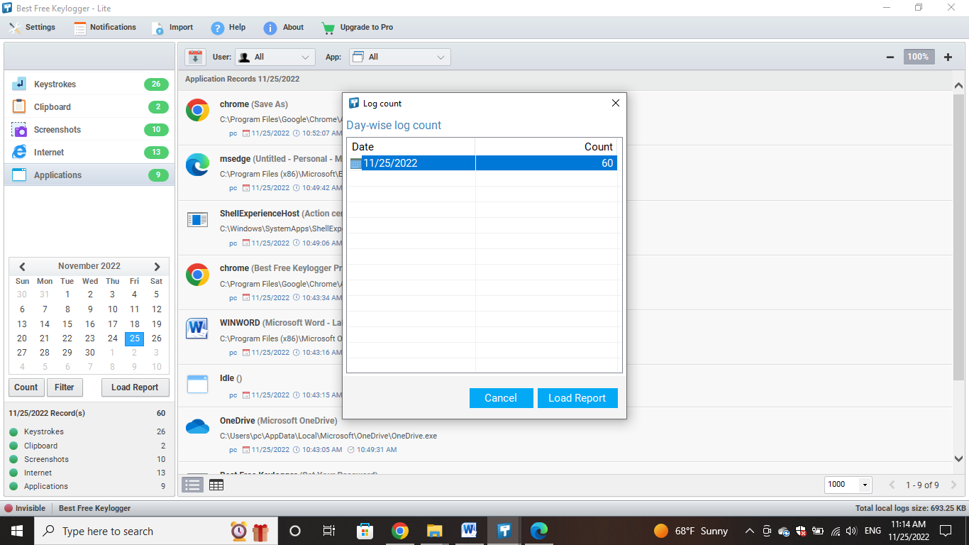

* **Filter**

Best Free Keylogger has facilities to search the information you want. Filtering can do for the generated reports by using user name or application name.

1. Click Filter button.

2. Enter your search criteria and click Apply button.

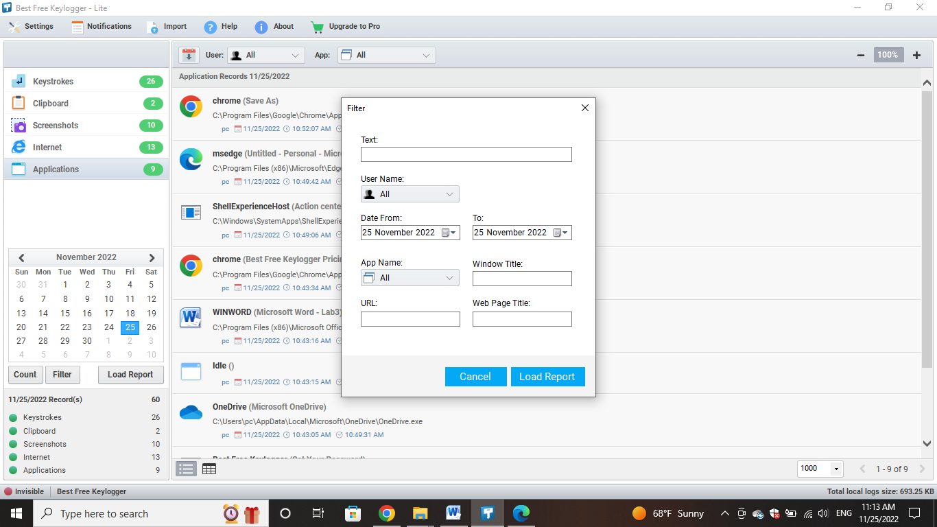

* **Load Report**

1. Select one out of Keystrokes, Clipboard, Screenshots or Internet activity.

2. Select the date you would like to view the logs for in the calendar.

3. Click Load Report button.

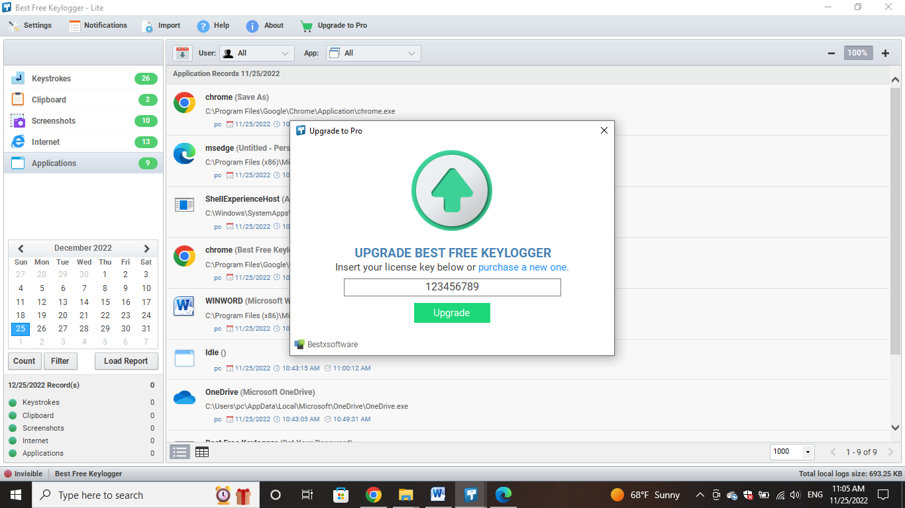

* **Upgrade**

After the purchase, you will receive a license key immediately via Email.

Click Upgrade to Pro button on the toolbar.

Enter your name and license key in the registration dialog.



* **Running**

Local data size: This will show the capacity takes for the log files.

### 